Pandas is a Python library used for working with data sets. It has functions for analyzing, cleaning, exploring, and manipulating data. The name "Pandas" has a reference to both "Panel Data", and "Python Data Analysis" and was created by Wes McKinney in 2008.
Pandas allows us to analyze big data and make conclusions based on statistical theories. Pandas can clean messy data sets, and make them readable and relevant. Relevant data is very important in data science.

Pandas gives you answers about the data. Like:
- Is there a correlation between two or more columns? What is average value?
- Max value? Min value?
Pandas are also able to delete rows that are not relevant, or contains wrong values, like empty or NULL values. This is called cleaning the data.
The source code for Pandas is located at this github repository https://github.com/pandas-dev/pandas

C:\Users\Your Name>pip install pandas -> Successfully installed pandas-1.5.2 pytz-2022.7
import pandas
import pandas as pd
mydataset = {
'cars': ["BMW", "Volvo", "Ford"],
'passings': [3, 7, 2]
}
myvar = pd.DataFrame(mydataset)
print(myvar)
cars passings
0 BMW 3
1 Volvo 7
2 Ford 2
Checking Pandas version
import pandas as pd
print(pd.__version__) 1.0.3

Pandas series. Like a columna in a table. One dimension array holding data of any type
import pandas as pd
a = [1, 7, 2]
myvar = pd.Series(a)
print(myvar)
0 1
1 7
2 2
dtype: int64

Create Labels
import pandas as pd
a = [1, 7, 2]
myvar = pd.Series(a, index = ["x", "y", "z"])
print(myvar)
x 1
y 7
z 2
dtype: int64
import pandas as pd
a = [1, 7, 2]
myvar = pd.Series(a, index = ["x", "y", "z"])
print(myvar["y"]) -> 7

Key/Value Objects as Series
You can also use a key/value object, like a dictionary, when creating a Series.
import pandas as pd
calories = {"day1": 420, "day2": 380, "day3": 390}
myvar = pd.Series(calories)
print(myvar)
day1 420
day2 380
day3 390
dtype: int64

import pandas as pd # only day 1 2
calories = {"day1": 420, "day2": 380, "day3": 390}
myvar = pd.Series(calories, index = ["day1", "day2"])
print(myvar)
day1 420
day2 380
dtype: int64

DataFrames. Data sets in Pandas are usually multi-dimensional tables, called DataFrames.
Series is like a column, a DataFrame is the whole table.
import pandas as pd
data = {
"calories": [420, 380, 390],
"duration": [50, 40, 45]
}
myvar = pd.DataFrame(data)
print(myvar) calories duration
0 420 50
1 380 40
2 390 45
Locate row
import pandas as pd
data = {
"calories": [420, 380, 390],
"duration": [50, 40, 45]
}
#load data into a DataFrame object:
df = pd.DataFrame(data)
print(df.loc[0])
calories 420
duration 50
Name: 0, dtype: int64

import pandas as pd # row 0 and 1
data = {
"calories": [420, 380, 390],
"duration": [50, 40, 45]
}
#load data into a DataFrame object:
df = pd.DataFrame(data)
print(df.loc[[0, 1]])
calories duration
0 420 50
1 380 40
Named Indexes
import pandas as pd
data = {
"calories": [420, 380, 390],
"duration": [50, 40, 45]
}
df = pd.DataFrame(data, index = ["day1", "day2", "day3"])
print(df)
calories duration
day1 420 50
day2 380 40
day3 390 45

import pandas as pd # located named indexes
data = {
"calories": [420, 380, 390],
"duration": [50, 40, 45]
}
df = pd.DataFrame(data, index = ["day1", "day2", "day3"])
print(df.loc["day2"])
calories 380
duration 40
Name: day2, dtype: int64

Load file into dataFrame
import pandas as pd
df = pd.read_csv('data.csv')
print(df)
Duration Pulse Maxpulse Calories
0 60 110 130 409.1
1 60 117 145 479.0
2 60 103 135 340.0
3 45 109 175 282.4
4 45 117 148 406.0
.. ... ... ... ...
164 60 105 140 290.8
165 60 110 145 300.4
166 60 115 145 310.2
167 75 120 150 320.4
168 75 125 150 330.4

[169 rows x 4 columns]

Read csv file use to_string() to print the entire DataFrame
import pandas as pd
df = pd.read_csv('data.csv')
print(df.to_string())

import pandas as pd # Withput to sring # firts 5 and last 5
df = pd.read_csv('data.csv')
print(df)
Duration Pulse Maxpulse Calories
0 60 110 130 409.1
1 60 117 145 479.0
2 60 103 135 340.0
3 45 109 175 282.4
4 45 117 148 406.0
.. ... ... ... ...
164 60 105 140 290.8
165 60 110 145 300.4
166 60 115 145 310.2
167 75 120 150 320.4
168 75 125 150 330.4

[169 rows x 4 columns]

import pandas as pd
print(pd.options.display.max_rows) -60

In my system the number is 60, which means that if the DataFrame contains more than 60 rows, the print(df), statement will return only the headers and the first and last 5 rows.You can change the máximum rows numbers with the same statement
import pandas as pd
pd.options.display.max_rows = 9999
df = pd.read_csv('data.csv')
print(df) _>168 rows

Pandas read JSON
Big data sets are often stored, or extracted as JSON. -> is plain text, but has the format of an object, and is well known in the world of programming, including Pandas. In our examples we will be using a JSON file: 'data.json'.

import pandas as pd # use to_string() to print the entire DataFrame.
df = pd.read_json('data.json')
print(df.to_string())
Duration Pulse Maxpulse Calories
0 60 110 130 409.1
1 60 117 145 479.0
2 60 103 135 340.0
3 45 109 175 282.4
4 45 117 148 406.0
5 60 102 127 300.5
.. 168 rows
Dictionary as Json. Json = Python Dictionary
If your JSON code is not in a file, but in a Python Dictionary, you can load it into a DataFrame directly:

import pandas as pd
data = {
"Duration":{
"0":60,
"1":60,
"2":60,
"3":45,
"4":45,
"5":60
},
"Pulse":{
"0":110,
"1":117,
"2":103,
"3":109,
"4":117,
"5":102
},
"Maxpulse":{
"0":130,
"1":145,
"2":135,
"3":175,
"4":148,
"5":127
},
"Calories":{
"0":409.1,
"1":479.0,
"2":340.0,
"3":282.4,
"4":406.0,
"5":300.5
}
}
df = pd.DataFrame(data)
print(df)
Duration Pulse Maxpulse Calories
0 60 110 130 409.1
1 60 117 145 479.0
2 60 103 135 340.0
3 45 109 175 282.4
4 45 117 148 406.0
5 60 102 127 300.5

Pandas. Analizing DataFrames. Head() method
import pandas as pd # first 10 rows
df = pd.read_csv('data.csv')
print(df.head(10))
Duration Pulse Maxpulse Calories
0 60 110 130 409.1
1 60 117 145 479.0
2 60 103 135 340.0
3 45 109 175 282.4
4 45 117 148 406.0
5 60 102 127 300.5
6 60 110 136 374.0
7 45 104 134 253.3
8 30 109 133 195.1
9 60 98 124 269.0

import pandas as pd # print first 5 rows
df = pd.read_csv('data.csv')
print(df.head())

import pandas as pd # tail method last 5 rows
df = pd.read_csv('data.csv')
print(df.tail())
Duration Pulse Maxpulse Calories
164 60 105 140 290.8
165 60 110 145 300.4
166 60 115 145 310.2
167 75 120 150 320.4
168 75 125 150 330.4

import pandas as pd # Prnt info about the data
df = pd.read_csv('data.csv')
print(df.info())
<class 'pandas.core.frame.DataFrame'>
RangeIndex: 169 entries, 0 to 168
Data columns (total 4 columns):
# Column Non-Null Count Dtype
--- ------ -------------- -----
0 Duration 169 non-null int64
1 Pulse 169 non-null int64
2 Maxpulse 169 non-null int64
3 Calories 164 non-null float64
dtypes: float64(1), int64(3)
memory usage: 5.4 KB
None

Null Values The info() method also tells us how many Non-Null values there are present in each column, and in our data set it seems like there are 164 of 169 Non-Null values in the "Calories" column. Which means that there are 5 rows with no value at all, in the "Calories" column, for whatever reason. Empty values, or Null values, can be bad when analyzing data, and you should consider removing rows with empty values. This is a step towards what is called cleaning data, and you will learn more about that in the next chapters.
Pandas Cleaning Data
Data cleaning means fixing bad data in your data set. Bad data could be:
- Empty cells Data in wrong format
- Wrong data Duplicates In this tutorial you will learn how to deal with all of them.

The data set contains some empty cells ("Date" in row 22, and "Calories" in row 18 and 28).
The data set contains wrong format ("Date" in row 26).
The data set contains wrong data ("Duration" in row 7).
The data set contains duplicates (row 11 and 12).

Duration Date Pulse Maxpulse Calories
0 60 '2020/12/01' 110 130 409.1
1 60 '2020/12/02' 117 145 479.0
2 60 '2020/12/03' 103 135 340.0
3 45 '2020/12/04' 109 175 282.4
4 45 '2020/12/05' 117 148 406.0
5 60 '2020/12/06' 102 127 300.0
6 60 '2020/12/07' 110 136 374.0
7 450 '2020/12/08' 104 134 253.3
8 30 '2020/12/09' 109 133 195.1
9 60 '2020/12/10' 98 124 269.0
10 60 '2020/12/11' 103 147 329.3
11 60 '2020/12/12' 100 120 250.7
12 60 '2020/12/12' 100 120 250.7
13 60 '2020/12/13' 106 128 345.3
14 60 '2020/12/14' 104 132 379.3
15 60 '2020/12/15' 98 123 275.0
16 60 '2020/12/16' 98 120 215.2
17 60 '2020/12/17' 100 120 300.0
18 45 '2020/12/18' 90 112 NaN
19 60 '2020/12/19' 103 123 323.0
20 45 '2020/12/20' 97 125 243.0
21 60 '2020/12/21' 108 131 364.2
22 45 NaN 100 119 282.0
23 60 '2020/12/23' 130 101 300.0
24 45 '2020/12/24' 105 132 246.0
25 60 '2020/12/25' 102 126 334.5
26 60 2020/12/26 100 120 250.0
27 60 '2020/12/27' 92 118 241.0
28 60 '2020/12/28' 103 132 NaN
29 60 '2020/12/29' 100 132 280.0
30 60 '2020/12/30' 102 129 380.3
31 60 '2020/12/31' 92 115 243.0

Empty Cells. Empty cells can potentially give you a wrong result when you analyze data.

Remove Rows. One way to deal with empty cells is to remove rows that contain empty cells. This is usually OK, since data sets can be very big, and removing a few rows will not have a big impact on the result.
import pandas as pd # the dropna() method returns a new DataFrame, and will not change the original.
df = pd.read_csv('data.csv')
new_df = df.dropna()
print(new_df.to_string())
#Notice in the result that some rows have been removed (row 18, 22 and 28). #These rows had cells with empty values.
Duration Date Pulse Maxpulse Calories
0 60 '2020/12/01' 110 130 409.1
1 60 '2020/12/02' 117 145 479.0
2 60 '2020/12/03' 103 135 340.0
3 45 '2020/12/04' 109 175 282.4
4 45 '2020/12/05' 117 148 406.0
5 60 '2020/12/06' 102 127 300.0
6 60 '2020/12/07' 110 136 374.0
7 450 '2020/12/08' 104 134 253.3
8 30 '2020/12/09' 109 133 195.1
9 60 '2020/12/10' 98 124 269.0
10 60 '2020/12/11' 103 147 329.3
11 60 '2020/12/12' 100 120 250.7
12 60 '2020/12/12' 100 120 250.7
13 60 '2020/12/13' 106 128 345.3
14 60 '2020/12/14' 104 132 379.3
15 60 '2020/12/15' 98 123 275.0
16 60 '2020/12/16' 98 120 215.2
17 60 '2020/12/17' 100 120 300.0
19 60 '2020/12/19' 103 123 323.0
20 45 '2020/12/20' 97 125 243.0
21 60 '2020/12/21' 108 131 364.2
23 60 '2020/12/23' 130 101 300.0
24 45 '2020/12/24' 105 132 246.0
25 60 '2020/12/25' 102 126 334.5
26 60 2020/12/26 100 120 250.0
27 60 '2020/12/27' 92 118 241.0
29 60 '2020/12/29' 100 132 280.0
30 60 '2020/12/30' 102 129 380.3
31 60 '2020/12/31' 92 115 243.0

import pandas as pd # the dropna(inplace = True) will NOT return a new DataFrame, but it will remove all rows containing NULL values from the original DataFrame.
df = pd.read_csv('data.csv')
df.dropna(inplace = True)
print(df.to_string())
#Notice in the result that some rows have been removed (row 18, 22 and 28). #These rows had cells with empty values.

import pandas as pd #Replace empty values df.fillna()
df = pd.read_csv('data.csv')
df.fillna(130, inplace = True)
print(df.to_string())
#Notice in the result: empty cells got the value 130 (in row 18, 22 and 28).

import pandas as pd # Replace Only For Specified Columns df[].fillna()
df = pd.read_csv('data.csv')
df["Calories"].fillna(130, inplace = True)
print(df.to_string())
#This operation inserts 130 in empty cells in the "Calories" column (row 18 and 28).

import pandas as pd # replave wuth the mean, median mode. Methos: mean() median() and mode()
df = pd.read_csv('data.csv')
x = df["Calories"].mean()
df["Calories"].fillna(x, inplace = True)
print(df.to_string())
#As you can see in row 18 and 28, the empty values from "Calories" was replaced with the mean: 304.68

import pandas as pd
df = pd.read_csv('data.csv')
x = df["Calories"].median()
df["Calories"].fillna(x, inplace = True)
print(df.to_string())
#As you can see in row 18 and 28, the empty values from "Calories" was replaced with the median: 291.2

import pandas as pd
df = pd.read_csv('data.csv')
x = df["Calories"].mode()[0]
df["Calories"].fillna(x, inplace = True)
print(df.to_string())
#As you can see in row 18 and 28, the empty value from "Calories" was replaced with the mode: 300.0

Pandas - Cleaning Data of Wrong Format. We have two cells with the wrong format. Check out row 22 and 26, the 'Date' column should be a string that represents a date:
import pandas as pd
df = pd.read_csv('data.csv')
df['Date'] = pd.to_datetime(df['Date'])
print(df.to_string())
22 45 NaT 100 119 282.0
23 60 2020-12-23 130 101 300.0
24 45 2020-12-24 105 132 246.0
25 60 2020-12-25 102 126 334.5
26 60 2020-12-26 100 120 250.0
27 60 2020-12-27 92 118 241.0

Removing Rows. The result from the converting in the example above gave us a NaT value, which can be handled as a NULL value, and we can remove the row by using the dropna() method.

import pandas as pd # remove a null value
df = pd.read_csv('data.csv')
df['Date'] = pd.to_datetime(df['Date'])
df.dropna(subset=['Date'], inplace = True)
print(df.to_string())
18 45 2020-12-18 90 112 NaN
19 60 2020-12-19 103 123 323.0
20 45 2020-12-20 97 125 243.0
21 60 2020-12-21 108 131 364.2
23 60 2020-12-23 130 101 300.0

Pandas. Fixing wrong data. "Wrong data" does not have to be "empty cells" or "wrong format", it can just be wrong, like if someone registered "199" instead of "1.99". Sometimes you can spot wrong data by looking at the data set, because you have an expectation of what it should be.
If you take a look at our data set, you can see that in row 7, the duration is 450, but for all the other rows the duration is between 30 and 60. It doesn't have to be wrong, but taking in consideration that this is the data set of someone's workout sessions, we conclude with the fact that this person did not work out in 450 minutes.
Replacing values
import pandas as pd
df = pd.read_csv('data.csv')
df.loc[7,'Duration'] = 45
print(df.to_string())
6 60 '2020/12/07' 110 136 374.0
7 45 '2020/12/08' 104 134 253.3
8 30 '2020/12/09' 109 133 195.1
9 60 '2020/12/10' 98 124 269.0

import pandas as pd # if the value is greater tan 120 set it to 120
df = pd.read_csv('data.csv')
for x in df.index:
if df.loc[x, "Duration"] > 120:
df.loc[x, "Duration"] = 120
print(df.to_string())

Removing Rows. Another way of handling wrong data is to remove the rows that contains wrong data. This way you do not have to find out what to replace them with, and there is a good chance you do not need them to do your analyses.

import pandas as pd
df = pd.read_csv('data.csv')
for x in df.index:
if df.loc[x, "Duration"] > 120:
df.drop(x, inplace = True)
#remember to include the 'inplace = True' argument to make the changes in the original DataFrame object instead of returning a copy
print(df.to_string()) # ver row 7 no existe mas
6 60 '2020/12/07' 110 136 374.0
8 30 '2020/12/09' 109 133 195.1
9 60 '2020/12/10' 98 124 269.0

Pandas – Removing duplicates
import pandas as pd
df = pd.read_csv('data.csv')
print(df.duplicated()) # example 11 12
10 False
11 False
12 True

import pandas as pd #df.drop_duplicates()
df = pd.read_csv('data.csv')
df.drop_duplicates(inplace = True)
print(df.to_string())
#Notice that row 12 has been removed from the result
10 60 '2020/12/11' 103 147 329.3
11 60 '2020/12/12' 100 120 250.7
13 60 '2020/12/13' 106 128 345.3
The (inplace = True) will make sure that the method does NOT return a new DataFrame, but it will remove all duplicates from the original DataFrame.

PANDAS – Data correlations Finding Relationships. A great aspect of the Pandas module is the corr() method. Calculates the relationship between each column in your data set. The examples in this page uses a CSV file called: 'data.csv'.
import pandas as pd # The corr() method ignores "not numeric" columns.
df = pd.read_csv('data.csv')
print(df.corr())
Duration Pulse Maxpulse Calories
Duration 1.000000 -0.059452 -0.250033 0.344341
Pulse -0.059452 1.000000 0.269672 0.481791
Maxpulse -0.250033 0.269672 1.000000 0.335392
Calories 0.344341 0.481791 0.335392 1.000000

Pandas Plotting plot() method. We can use Pyplot, a submodule of the Matplotlib library to visualize the diagram on the screen. Read more about Matplotlib in our Matplotlib Tutorial.

#Three lines to make our compiler able to draw:
import sys
import matplotlib
matplotlib.use('Agg')
import pandas as pd
import matplotlib.pyplot as plt
df = pd.read_csv('data.csv')
df.plot()
plt.show()
#Two lines to make our compiler able to draw:
plt.savefig(sys.stdout.buffer)
sys.stdout.flush()
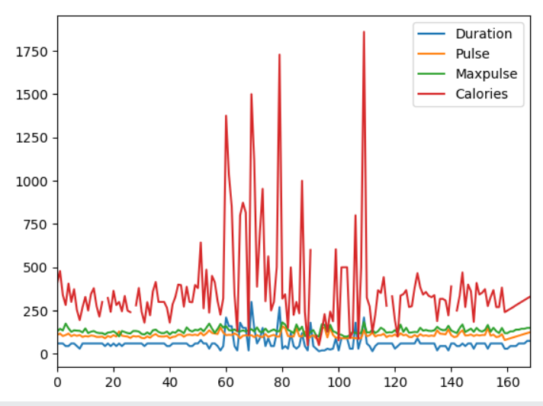

#Three lines to make our compiler able to draw:
import sys
import matplotlib
matplotlib.use('Agg')
import pandas as pd # scatter plot
import matplotlib.pyplot as plt
df = pd.read_csv('data.csv')
df.plot(kind = 'scatter', x = 'Duration', y = 'Calories')
plt.show()
#Two lines to make our compiler able to draw:
plt.savefig(sys.stdout.buffer)
sys.stdout.flush()
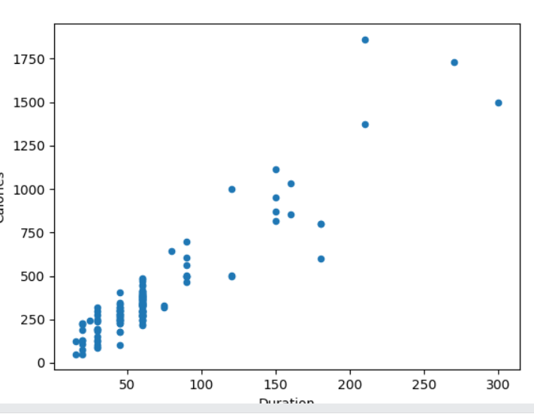
In the previous example, we learned ->The correlation between "Duration" and "Calories" was 0.922721, and we concluded with the fact that higher duration means more calories burned. By looking at the scatterplot, I will agree.

#Three lines to make our compiler able to draw: bad relationship between the columns, like "Duration" and "Maxpulse", with the correlation 0.009403:
import sys
import matplotlib
matplotlib.use('Agg')
import pandas as pd
import matplotlib.pyplot as plt
df = pd.read_csv('data.csv')
df.plot(kind = 'scatter', x = 'Duration', y = 'Maxpulse')
plt.show()
#Two lines to make our compiler able to draw:
plt.savefig(sys.stdout.buffer)
sys.stdout.flush()
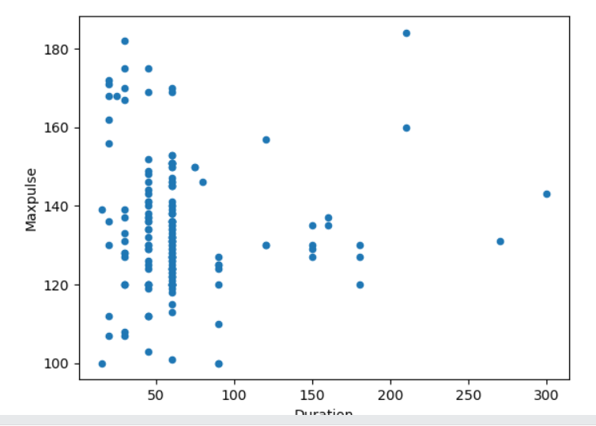
Histogram #Three lines to make our compiler able to draw: # kind = 'hist'
import sys
import matplotlib
matplotlib.use('Agg')
import pandas as pd
import matplotlib.pyplot as plt
df = pd.read_csv('data.csv')
df["Duration"].plot(kind = 'hist')
plt.show()
#Two lines to make our compiler able to draw:
plt.savefig(sys.stdout.buffer)
sys.stdout.flush()
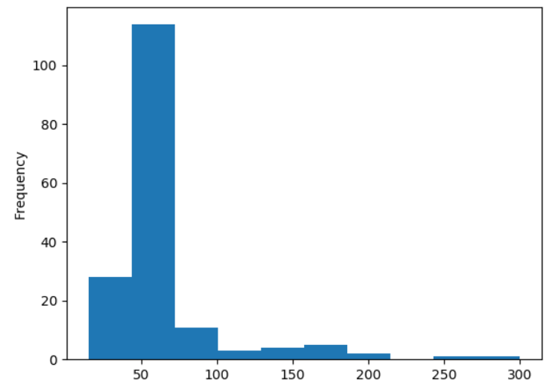
Ddd

